20170214
# Not official

Protected: graylog add UDP GELF collector
Posted on November 21, 2016 by fam
начинаем с инпутов на балансерах(keepalived), смотрим доступный порт:
ssh ds-graylog-lb01 (активная нода баналсера)
[root@ds-graylog-lb01 a.leonov]# ll /etc/keepalived/conf.d/ |sort
-rw-r–r– 1 root root 604 Nov 1 16:15 tcp-443-input.conf
-rw-r–r– 1 root root 607 Nov 1 16:15 udp-8702-input.conf
-rw-r–r– 1 root root 610 Nov 1 16:15 udp-12380-input.conf
-rw-r–r– 1 root root 610 Nov 1 16:15 udp-12390-input.conf
-rw-r–r– 1 root root 610 Nov 1 16:15 udp-12410-input.conf
total 116
[root@ds-graylog-lb01 a.leonov]#
последний занятый порт 12410. берем следующий по порядку:
1  2  3  4  5  6  7  8  9  10  11  12  13  14  15  16  17  18  19  20  21  22  23  24  25  26  27  28  29  30  31  32  33 | [root@ds-graylog-lb01 a.leonov]# cp /etc/keepalived/conf.d/udp-12410-input.conf /etc/keepalived/conf.d/udp-12411-input.conf  [root@ds-graylog-lb01 a.leonov]# vim /etc/keepalived/conf.d/udp-12411-input.conf  [root@ds-graylog-lb01 a.leonov]# cat /etc/keepalived/conf.d/udp-12411-input.conf  virtual_server 10.216.40.170 12411 {  delay_loop 6  lb_algo rr  lb_kind NAT  protocol UDP  real_server 10.217.26.4 12411 {  weight 1  SSL_GET {  url {  path /api/system/lbstatus  status_code 200  }  connect_port 443  connect_timeout 2  }  }  real_server 10.217.26.3 12411 {  weight 1  SSL_GET {  url {  path /api/system/lbstatus  status_code 200  }  connect_port 443  connect_timeout 2  }  }  }
копируем конфиг на stb-ноду:
1  2  3  4 | [root@ds-graylog-lb01 a.leonov]# scp /etc/keepalived/conf.d/udp-12411-input.conf root@m1-graylog-lb01:/etc/keepalived/conf.d/  root@m1-graylog-lb01's password:  udp-12411-input.conf 100% 610 0.6KB/s 00:00  [root@ds-graylog-lb01 a.leonov]#
применяем конфигурацию на stb-ноде:
1  2  3  4  5 | [root@ds-graylog-lb01 a.leonov]# ssh root@m1-graylog-lb01 service keepalived restart  root@m1-graylog-lb01's password:  Stopping keepalived: [ OK ]  Starting keepalived: [ OK ]  [root@ds-graylog-lb01 a.leonov]#
после успешного применения на stb-ноде, применяем на active-ноде:
1  2  3  4 | [root@ds-graylog-lb01 a.leonov]# /etc/init.d/keepalived restart  Stopping keepalived: [ OK ]  Starting keepalived: [ OK ]  [root@ds-graylog-lb01 a.leonov]#
проверяем доступность портов:
1  2  3  4  5  6  7  8 | [root@ds-graylog-lb01 a.leonov]# ipvsadm -L -n |grep 12411 ; ssh m1-graylog-lb01 'ipvsadm -L -n |grep 12411'  UDP 10.216.40.170:12411 rr  -> 10.217.26.3:12411 Masq 1 0 0  -> 10.217.26.4:12411 Masq 1 0 0  UDP 10.216.40.170:12411 rr  -> 10.217.26.3:12411 Masq 1 0 0  -> 10.217.26.4:12411 Masq 1 0 0  [root@ds-graylog-lb01 a.leonov]#
теперь в вебморду, сначала inputs:
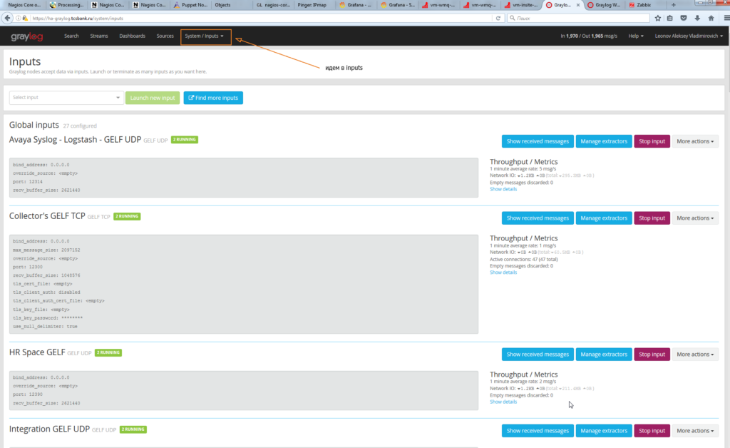
заводим новый input
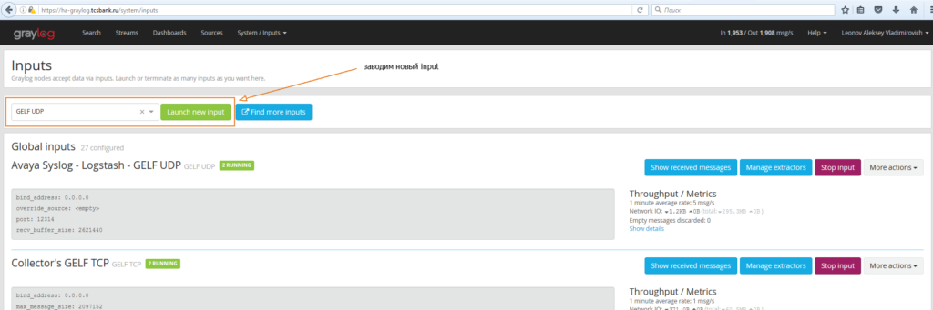
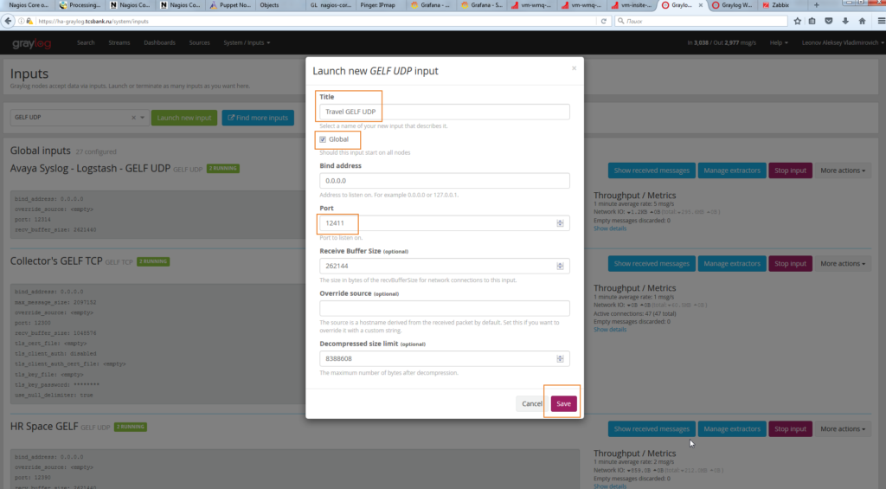
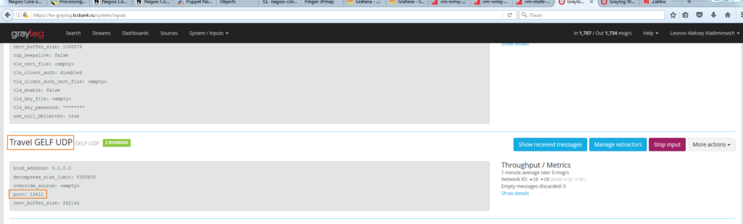
смотрим и запоминаем (в блокнот) input id:
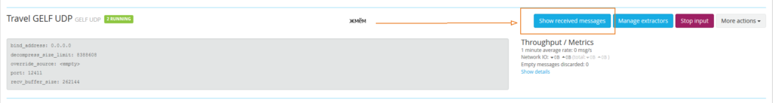
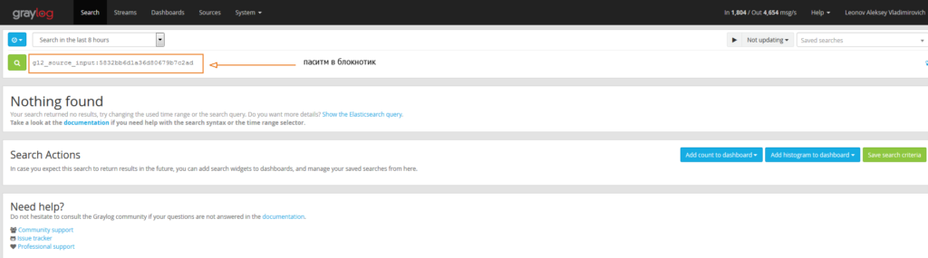
теперь идём в streams и заводим новый stream:
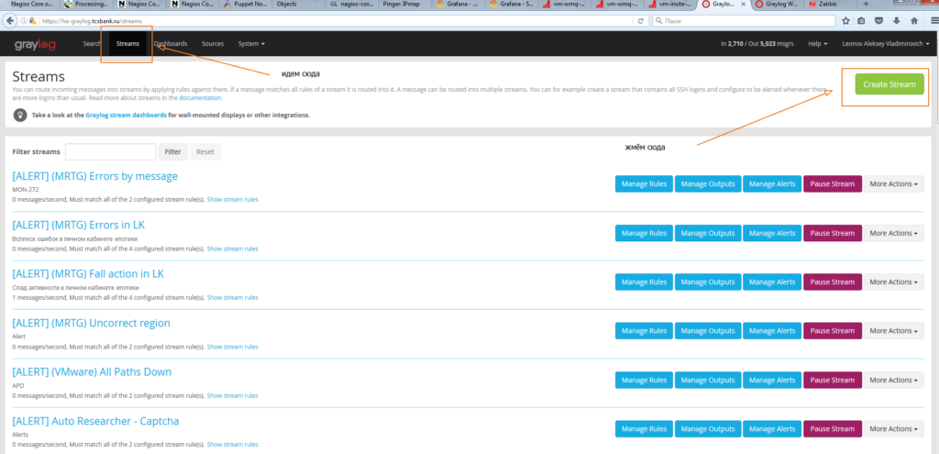
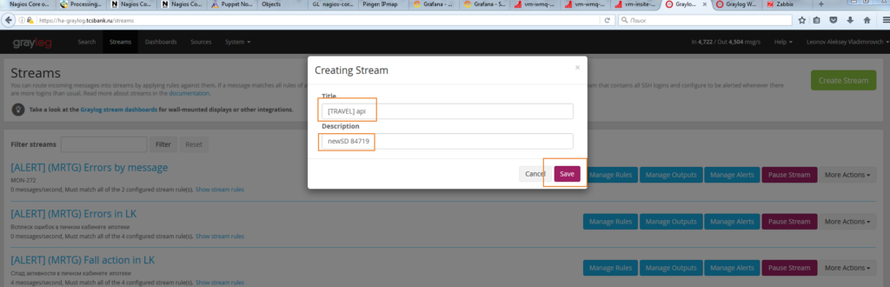
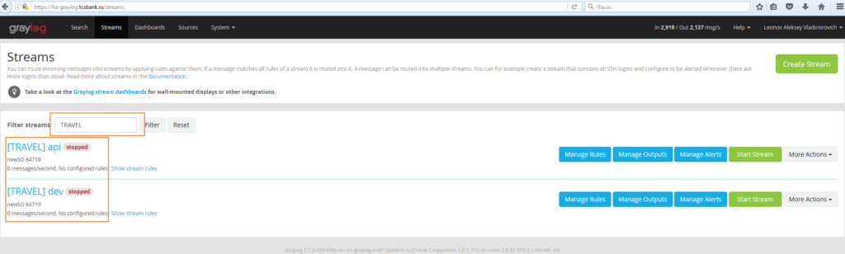
правим правила приема сообщений (вот тут и пригодится наш input id):
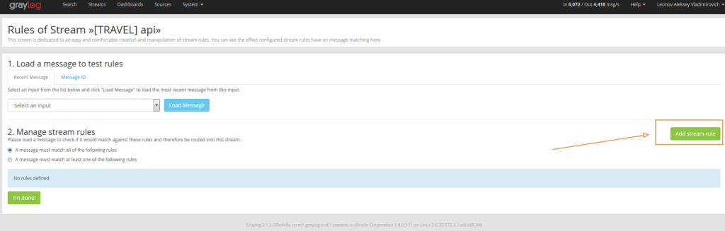
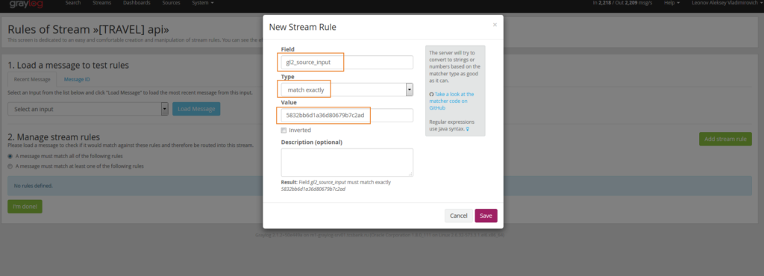
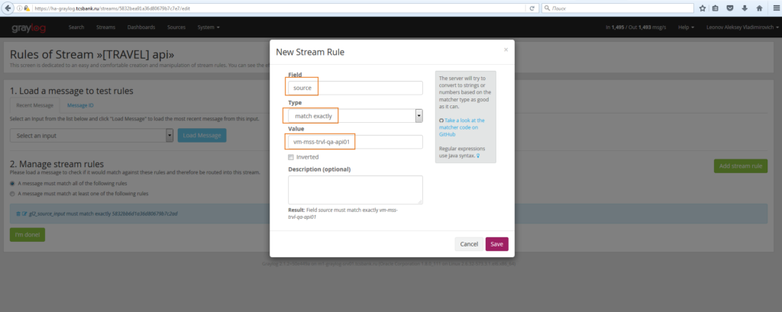
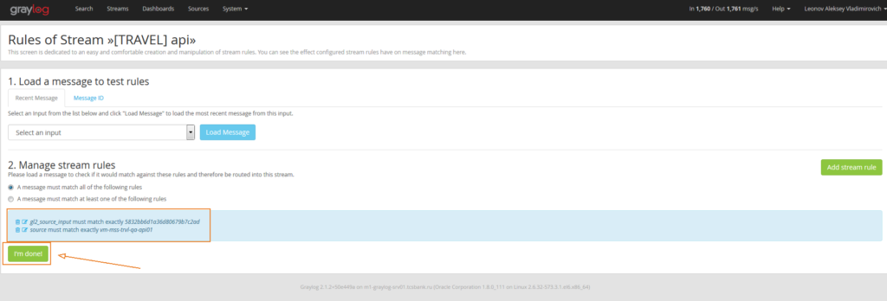
получится что-то подобное:
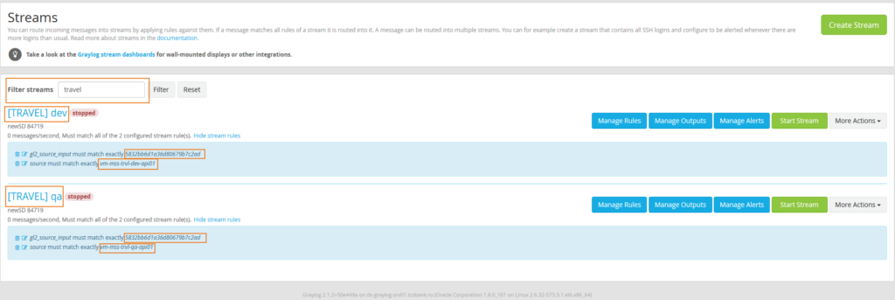
т.е мы используем один источник для обоих потоков, но разделяем сообщения по хосту-источнику. можно запускать потоки, запрашивать разрешения у сетевиков, и требовать у заказчика перенаправления логов на UDP ha-graylog.tcsbank.ru:12411
всё

# Received from Leonov.

Protected: graylog sidecar установка настройка
Posted on November 23, 2016 by fam
качаем:
sidecar
nxlog
и ставим на сервер источник логов:
1  2  3 | #cd /home/a.leonov  #yum localinstall ./collector-sidecar-0.0.9-1.x86_64.rpm  #yum localinstall ./nxlog-ce-2.9.1716-1_rhel6.x86_64.rpm
запускаем nxlog:
1  2  3  4  5  6 | #chkconfig nxlog on  #touch /var/log/logmsg2.txt  #touch /var/log/logmsg.txt  #chown nxlog /var/log/logmsg2.txt  #chown nxlog /var/log/logmsg.txt  #/etc/init.d/nxlog start
смотрим, стартовал ли:
1  2 | #cat /var/log/nxlog/nxlog.log  2016-11-23 10:30:58 INFO nxlog-ce-2.9.1716 started
настраиваем коляску:
1  2  3  4  5  6  7  8  9  10  11  12  13  14  15  16  17  18  19  20  21  22  23 | #mcedit /etc/graylog/collector-sidecar/collector_sidecar.yml  #cat /etc/graylog/collector-sidecar/collector_sidecar.yml  server_url: http://graylog.ti.local/api/  update_interval: 10  tls_skip_verify: false  send_status: true  list_log_files:  node_id: ds-informatica02t  collector_id: file:/etc/graylog/collector-sidecar/collector-id  log_path: /var/log/graylog/collector-sidecar  log_rotation_time: 86400  log_max_age: 604800  tags:  - ds-informatica02t  backends:  - name: nxlog  enabled: true  binary_path: /usr/bin/nxlog  configuration_path: /etc/graylog/collector-sidecar/generated/nxlog.conf  - name: filebeat  enabled: false  binary_path: /usr/bin/filebeat  configuration_path: /etc/graylog/collector-sidecar/generated/filebeat.yml
запускаем коляску:
1  2  3  4  5 | graylog-collector-sidecar -service install  #/etc/init.d/collector-sidecar start  Starting collector-sidecar  #/etc/init.d/collector-sidecar status  Running
теперь graylog, идем на балансер:
1  2  3  4  5  6  7  8  9  10  11  12  13  14  15  16  17  18  19  20  21  22  23  24  25  26  27  28  29  30  31  32  33  34  35  36  37  38  39  40  41  42  43  44 | # ssh m1-ins-lb01  # cd /etc/keepalived/conf.d/  # cp ./udp-12403-input.conf ./udp-12404-input.conf  # vim ./udp-12404-input.conf  # cat ./udp-12404-input.conf  virtual_server 10.218.50.20 12404 {  delay_loop 6  lb_algo rr  lb_kind NAT  nat_mask 255.255.255.0  protocol UDP  ops  real_server 10.217.27.4 12404 {  weight 1  HTTP_GET {  url {  path /api/system/lbstatus  status_code 200  }  connect_port 80  connect_timeout 2  }  }  real_server 10.217.27.3 12404 {  weight 1  HTTP_GET {  url {  path /api/system/lbstatus  status_code 200  }  connect_port 80  connect_timeout 2  }  }  }  # scp ./udp-12404-input.conf ds-ins-lb01:/etc/keepalived/conf.d/  # ssh ds-ins-lb01 /etc/init.d/keepalived restart  # /etc/init.d/keepalived restart  # ipvsadm -Ln |grep 12404  UDP 10.218.50.20:12404 rr ops  -> 10.217.27.3:12404 Masq 1 0 0  -> 10.217.27.4:12404 Masq 1 0 0
правим на хосте источнике /etc/nxlog.conf на предмет нового порта назначения (12404)
1  2  3  4  5  6  7  8  9  10  11  12  13  14  15  16  17  18  19  20  21  22  23  24  25  26  27  28  29  30  31  32  33  34  35  36  37  38  39  40 | User nxlog  Group nxlog  LogFile /var/log/nxlog/nxlog.log  LogLevel INFO  <Extension _syslog>  Module xm_syslog  </Extension>  <Input in1>  Module im_udp  Port 12404  Exec parse_syslog_bsd();  </Input>  <Input in2>  Module im_tcp  Port 12404  </Input>  <Output fileout1>  Module om_file  File "/var/log/logmsg.txt"  Exec if $Message =~ /error/ $SeverityValue = syslog_severity_value("error");  Exec to_syslog_bsd();  </Output>  <Output fileout2>  Module om_file  File "/var/log/logmsg2.txt"  </Output>  <Route 1>  Path in1 => fileout1  </Route>  <Route tcproute>  Path in2 => fileout2  </Route>

http://docs.graylog.org/en/2.1/pages/collector_sidecar.html

Graylog Collector Sidecar
Graylog Collector Sidecar is a lightweight configuration management system for different log collectors, also called Backends. The Graylog node(s) act as a centralized hub containing the configurations of log collectors. On supported message-producing devices/hosts, Sidecar can run as a service (Windows host) or daemon (Linux host).
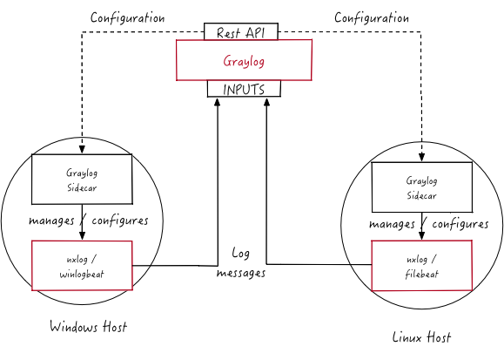
These configurations are centrally managed through the Graylog web interface, in a graphical way. For specific needs, raw backend configurations, called Snippets, may optionally be directly stored into Graylog.
Periodically, the Sidecar daemon will fetch all relevant configurations for the target, using the REST API. Which configurations are actually fetched depends on ‘tags’ defined in the host’s Sidecar configuration file. For instance, a Web server host may include the linux and nginx tags.
On its first run, or when a configuration change has been detected, Sidecar will generate (render) relevant backend configuration files. Then it will start, or restart, those reconfigured log collectors.
Graylog Collector Sidecar (written in Go) and backends (written in various languages, such as C and Go) are meant as a small-footprint replacement for the deprecated, Java-based deprecated Graylog Collector.

Backends
Currently the Sidecar is supporting NXLog, Filebeat and Winlogbeat. They all share the same web interface. Switch the tab on a configuration page to create resources for the used collector. The supported features are almost the same. For all collectors a GELF output with SSL encryption is available. The most used input options like file tailing or windows event logging do exist. On the server side you can share inputs with multiple collectors. E.g. All Filebeat and Winlogbeat instances can send logs into a single Graylog-Beats input.

Installation
Currently we provide pre-compiled packages on the Github releases page of the project. Once the Sidecar project is settled and matured we will add the packages to the DEB and YUM online repositories. To get the Sidecar working Download a package and install it on the target system.
All following commands should be executed on the remote machine where you want to collect log data from.

Beats backend

Ubuntu
The Beats binaries (Filebeat and Winlogeventbeat) are included in the Sidecar package. So installation is just one command:
$ sudo dpkg -i collector-sidecar_0.0.9-1_amd64.deb
Edit /etc/graylog/collector-sidecar/collector_sidecar.yml, you should set at least the correct URL to your Graylog server and proper tags. The tags are used to define which configurations the host should receive.
Create a system service and start it:
$ sudo graylog-collector-sidecar -service install
$ sudo start collector-sidecar

CentOS
Install the RPM package on RedHat based systems
$ sudo rpm -i collector-sidecar-0.0.9-1.x86_64.rpm
Activate the Sidecar as a system service:
$ sudo graylog-collector-sidecar -service install
$ sudo systemctl start collector-sidecar

Windows
Use the Windows installer, it can be run interactively:
$ collector_sidecar_installer.exe
or in silent mode with:
$ collector_sidecar_installer.exe /S
Edit C:\Program Files\graylog\collector-sidecar\collector_sidecar.yml and register the system service:
$ "C:\Program Files\graylog\collector-sidecar\graylog-collector-sidecar.exe" -service install
$ "C:\Program Files\graylog\collector-sidecar\graylog-collector-sidecar.exe" -service start

NXLog backend

Ubuntu
Install the NXLog package from the offical download page. Because the Sidecar takes control of stopping and starting NXlog it’s necessary to stop all running instances of NXlog and deconfigure the default system service. Afterwards we can install and setup the Sidecar:
$ sudo /etc/init.d/nxlog stop
$ sudo update-rc.d -f nxlog remove
$ sudo gpasswd -a nxlog adm
$ sudo chown -R nxlog.nxlog /var/spool/collector-sidecar/nxlog
$ sudo dpkg -i collector-sidecar_0.0.9-1_amd64.deb
Edit /etc/graylog/collector-sidecar/collector_sidecar.yml accordingly and register the Sidecar as a service:
$ sudo graylog-collector-sidecar -service install
$ sudo start collector-sidecar

CentOS
The same on a RedHat based system:
$ sudo service nxlog stop
$ sudo chkconfig --del nxlog
$ sudo gpasswd -a nxlog root
$ sudo chown -R nxlog.nxlog /var/spool/collector-sidecar/nxlog
$ sudo rpm -i collector-sidecar-0.0.9-1.x86_64.rpm
Activate the Sidecar as a system service:
$ sudo graylog-collector-sidecar -service install
$ sudo systemctl start collector-sidecar

Windows
Install the NXLog package from the offical download page and deactive the system service. We just need the binaries installed on the system:
$ C:\Program Files (x86)\nxlog\nxlog -u
$ collector_sidecar_installer.exe
Edit C:\Program Files\graylog\collector-sidecar\collector_sidecar.yml, you should set at least the correct URL to your Graylog server and proper tags. Register the system service:
$ C:\Program Files\graylog\collector-sidecar\graylog-collector-sidecar.exe -service install
$ C:\Program Files\graylog\collector-sidecar\graylog-collector-sidecar.exe -service start
To perform an uninstall on Windows:
$ C:\Program Files\graylog\collector-sidecar\graylog-collector-sidecar.exe -service stop
$ C:\Program Files\graylog\collector-sidecar\graylog-collector-sidecar.exe -service uninstall
Notice that the NXLog file input is currently not able to do a SavePos for file tailing, this will be fixed in a future version.

Configuration
On the command line you can provide a path to the configuration file with the -c switch. If no path is specified it looks on Linux systems for:
/etc/graylog/collector-sidecar/collector_sidecar.yml
and on Windows machines under:
C:\Program Files\graylog\collector-sidecar\collector_sidecar.yml
The configuration file is separated into global options and backend specific options. Global options are:
Parameter | Description
server_url | URL to the Graylog API, e.g. http://127.0.0.1:9000/api/
update_interval | The interval in seconds the sidecar will fetch new configurations from the Graylog server
tls_skip_verify | Ignore errors when the REST API was started with a self-signed certificate
send_status | Send the status of each backend back to Graylog and display it on the status page for the host
list_log_files | Send a directory listing to Graylog and display it on the host status page, e.g. /var/log. This can also be a list of directories
node_id | Name of the Sidecar instance, will also show up in the web interface. Hostname will be used if not set.
collector_id | Unique ID (UUID) of the instance. This can be a string or a path to an ID file
log_path | A path to a directory where the Sidecar can store the output of each running collector backend
log_rotation_time | Rotate the stdout and stderr logs of each collector after X seconds
log_max_age | Delete rotated log files older than Y seconds
tags | List of configuration tags. All configurations on the server side that match the tag list will be fetched and merged by this instance
backends | A list of collector backends the user wants to run on the target host
Currently NXLog and Beats are supported as collector backend, to make it work the Sidecar needs to know where the binary is installed and where it can write a configuration file for it.
Parameter | Description
name | Which backend to use (must be ‘nxlog’, ‘filebeat’ or ‘winlogbeat)
enabled | Whether this backend should be started by the Sidecar or not
binary_path | Path to the actual collector binary
configuration_path | Path to the configuration file for this collector
An example configuration for NXlog looks like this:
server_url: http://10.0.2.2:9000/api/
update_interval: 30
tls_skip_verify: true
send_status: true
list_log_files:
- /var/log
node_id: graylog-collector-sidecar
collector_id: file:/etc/graylog/collector-sidecar/collector-id
log_path: /var/log/graylog/collector-sidecar
log_rotation_time: 86400
log_max_age: 604800
tags:
- linux
- apache
- redis
backends:
- name: nxlog
enabled: true
binary_path: /usr/bin/nxlog
configuration_path: /etc/graylog/collector-sidecar/generated/nxlog.conf
For the Beats platform you can enable each Beat individually, e.g on a Windows host with Filebeat and Winlogbeat enabled use a configuration like this:
server_url: http://10.0.2.2:9000/api/
update_interval: 30
tls_skip_verify: true
send_status: true
list_log_files:
- /var/log
node_id: graylog-collector-sidecar
collector_id: file:/etc/graylog/collector-sidecar/collector-id
log_path: /var/log/graylog/collector-sidecar
log_rotation_time: 86400
log_max_age: 604800
tags:
- linux
- apache
- redis
backends:
- name: winlogbeat
enabled: true
binary_path: C:\Program Files\graylog\collector-sidecar\winlogbeat.exe
configuration_path: C:\Program Files\graylog\collector-sidecar\generated\winlogbeat.yml
- name: filebeat
enabled: true
binary_path: C:\Program Files\graylog\collector-sidecar\filebeat.exe
configuration_path: C:\Program Files\graylog\collector-sidecar\generated\filebeat.yml

First start
Once you installed the Sidecar package you are ready to start the service for the first time. Decide which backend you want to use. Enable or disable the single backends by setting enabled: true or respectively to false. Now start the Sidecar, depending on your operating system you can do this with:
Debian/Ubuntu | sudo start collector-sidecar
RedHat/CentOS | sudo systemctl start collector-sidecar
Windows | C:\Program Files\graylog\collector-sidecar\graylog-collector-sidecar.exe -service start
Afterwards you will most likely see an error like this in the log file:
INFO[0006] [RequestConfiguration] No configuration found for configured tags!
This simply means that there is no configuration with the same tag that the Sidecar was started with. So we have to create a new configuration. Define outputs and inputs and tag it in order to collect log files. Take the Step-by-step guide to create your first configuration.
When the Sidecar can find a configuration that matches it’s own tags, it will write for each collector backend a configuration file into the /generated directory. E.g. if you enabled the Filebeat collector you will find a filebeat.yml file in that directory. All changes have to be made in the Graylog web interface. Everytime the Sidecar detects an update to it’s configuration it will rewrite the corresponding collector configuration file. So it doesn’t make sense to manually edit those files.
Everytime a collector configuration file is changed the collector process is restarted. The Sidecar takes care of the collector processes and reports the status back to the web interface

Sidecar Status
Each Sidecar instance is able to send status informations back to Graylog. By enabling the option send_status metrics like the configured tags or the IP address of the host Sidecar is running on are send. Also metrics that are relevant for a stable operation e.g. disk volumes over 75% utilization are included. Additionaly with the list_log_files option a directory listing is displayed in the Graylog web interface. In that way an administrator can see which files are available for collecting. The list is periodically updated and files with write access are highlighted for easy identification. After enabling send_status or send_status + list_log_files go to the collector overview and click on one of them, a status page with the configured information will be displayed.

Step-by-step guide
We have prepared an example on how to configure the Sidecar using the Graylog Webinterface. The assumption is that we want to collect Apache logfiles and ship them with a Filebeat collector to a Beats input that is listening on Port 5044 on your Graylog Server.
- The first step is to create a Beats input where collectors can send data to. Click on System → Inputs and start a global Beats input on the listening address 0.0.0.0 and port 5044.
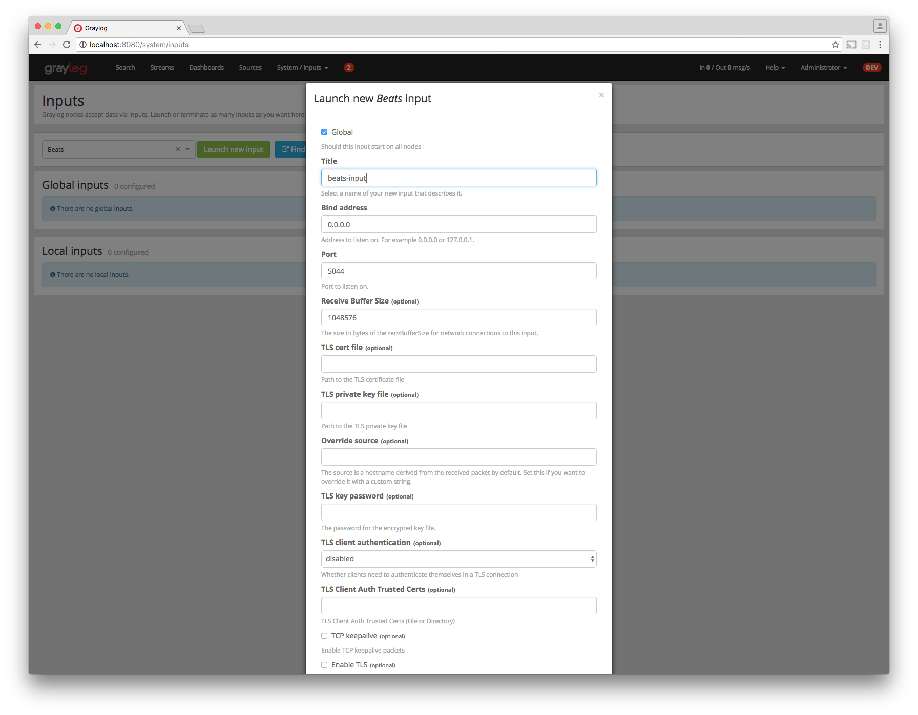
- Navigate to the collector configurations. In your Graylog Webinterface click on System → Collectors → Manage configurations.
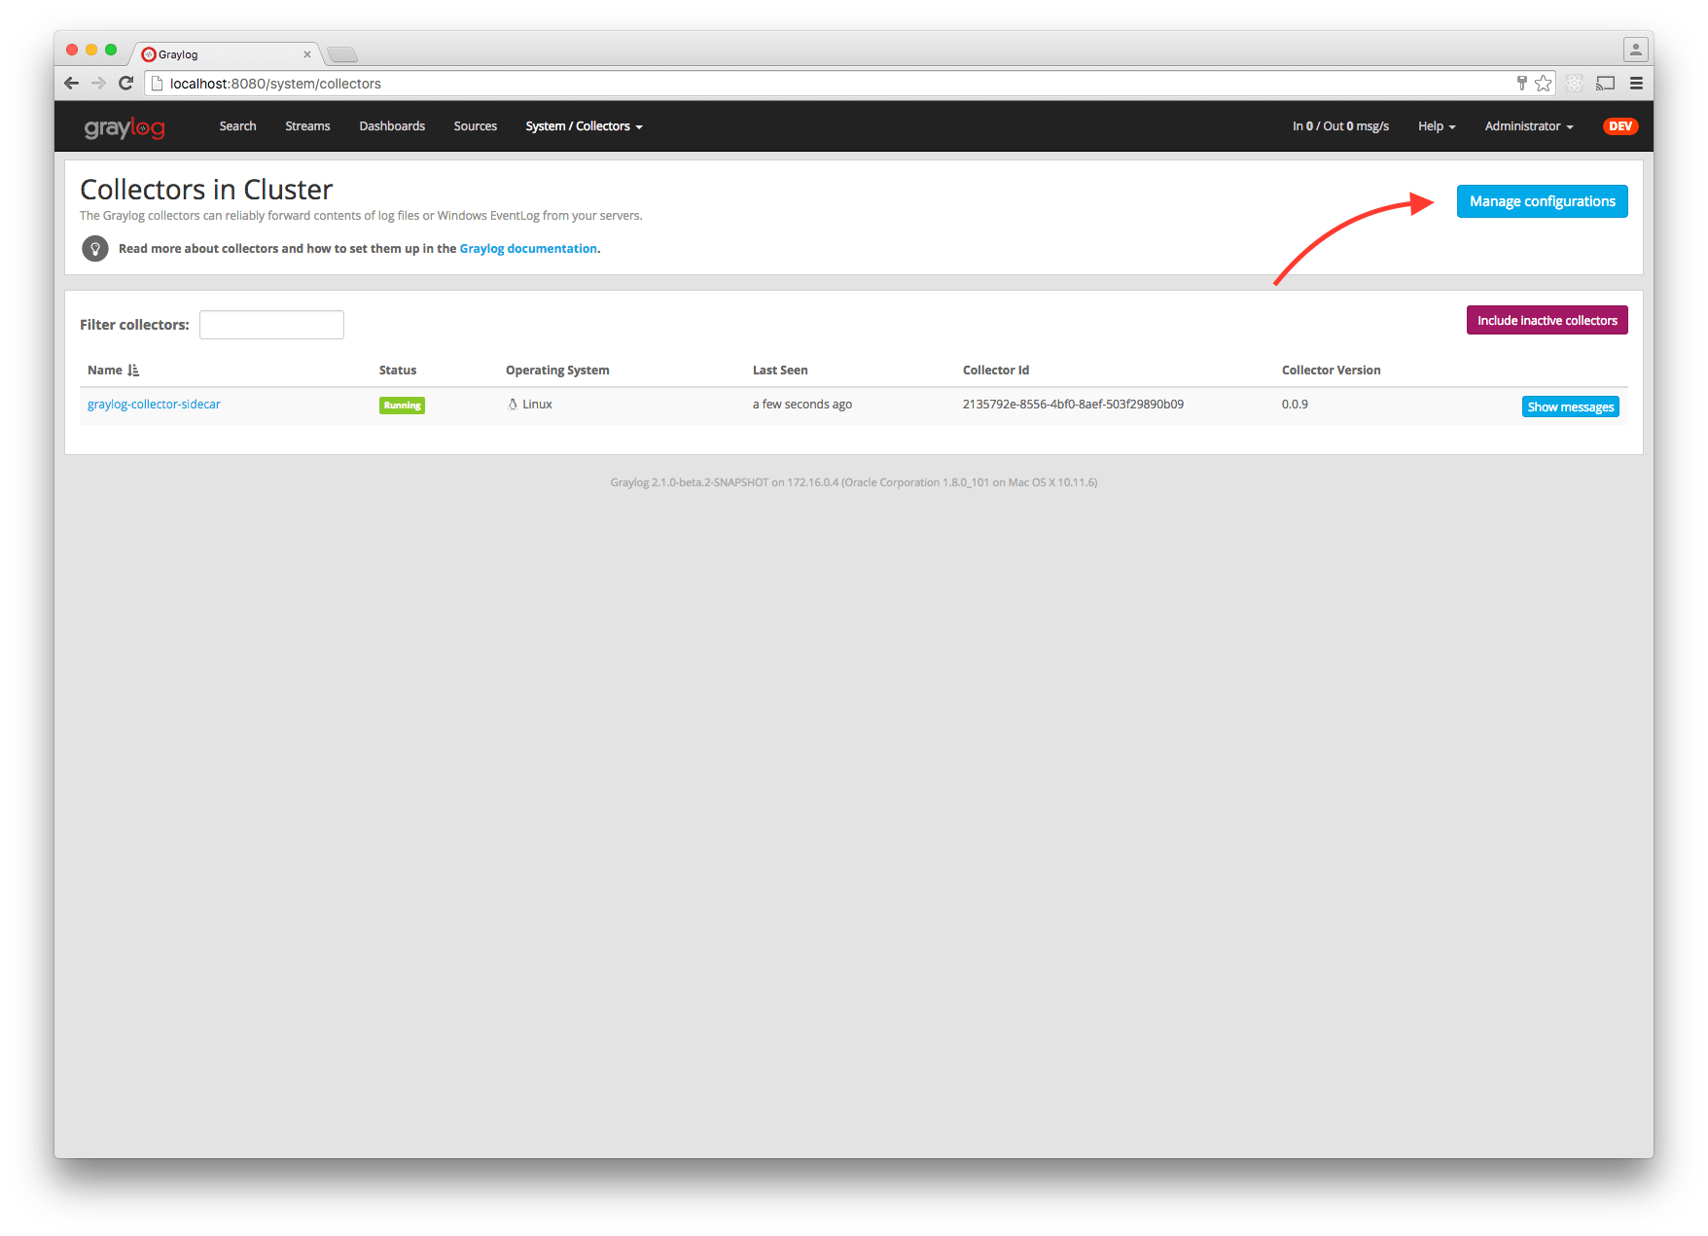
- Next we create a new configuration
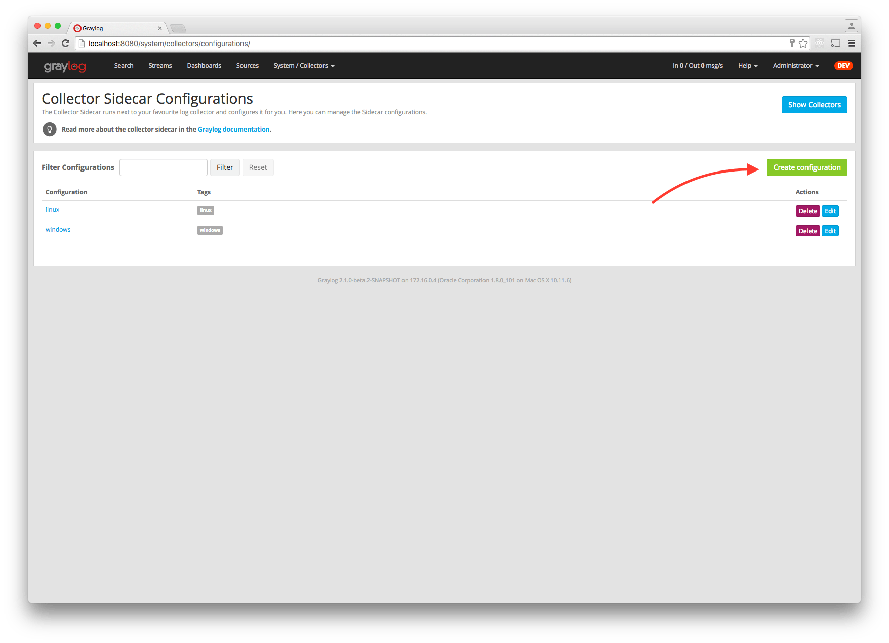
- Give the configuration a name
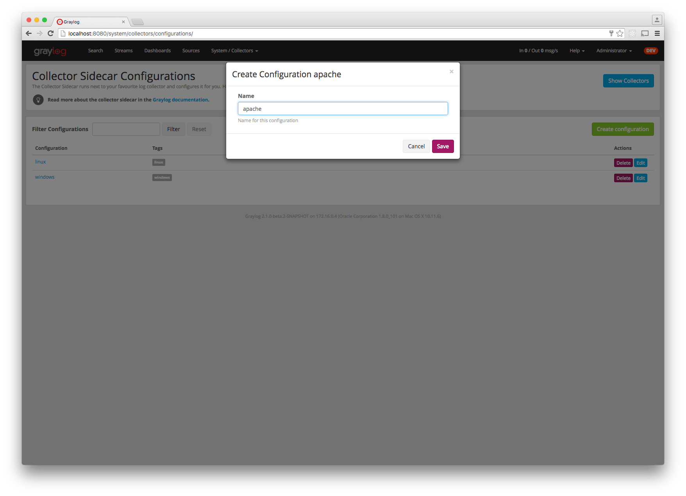
- Click on the new configuration and create e.g. a Filebeat output. For a first test just change the IP to your Graylog server.
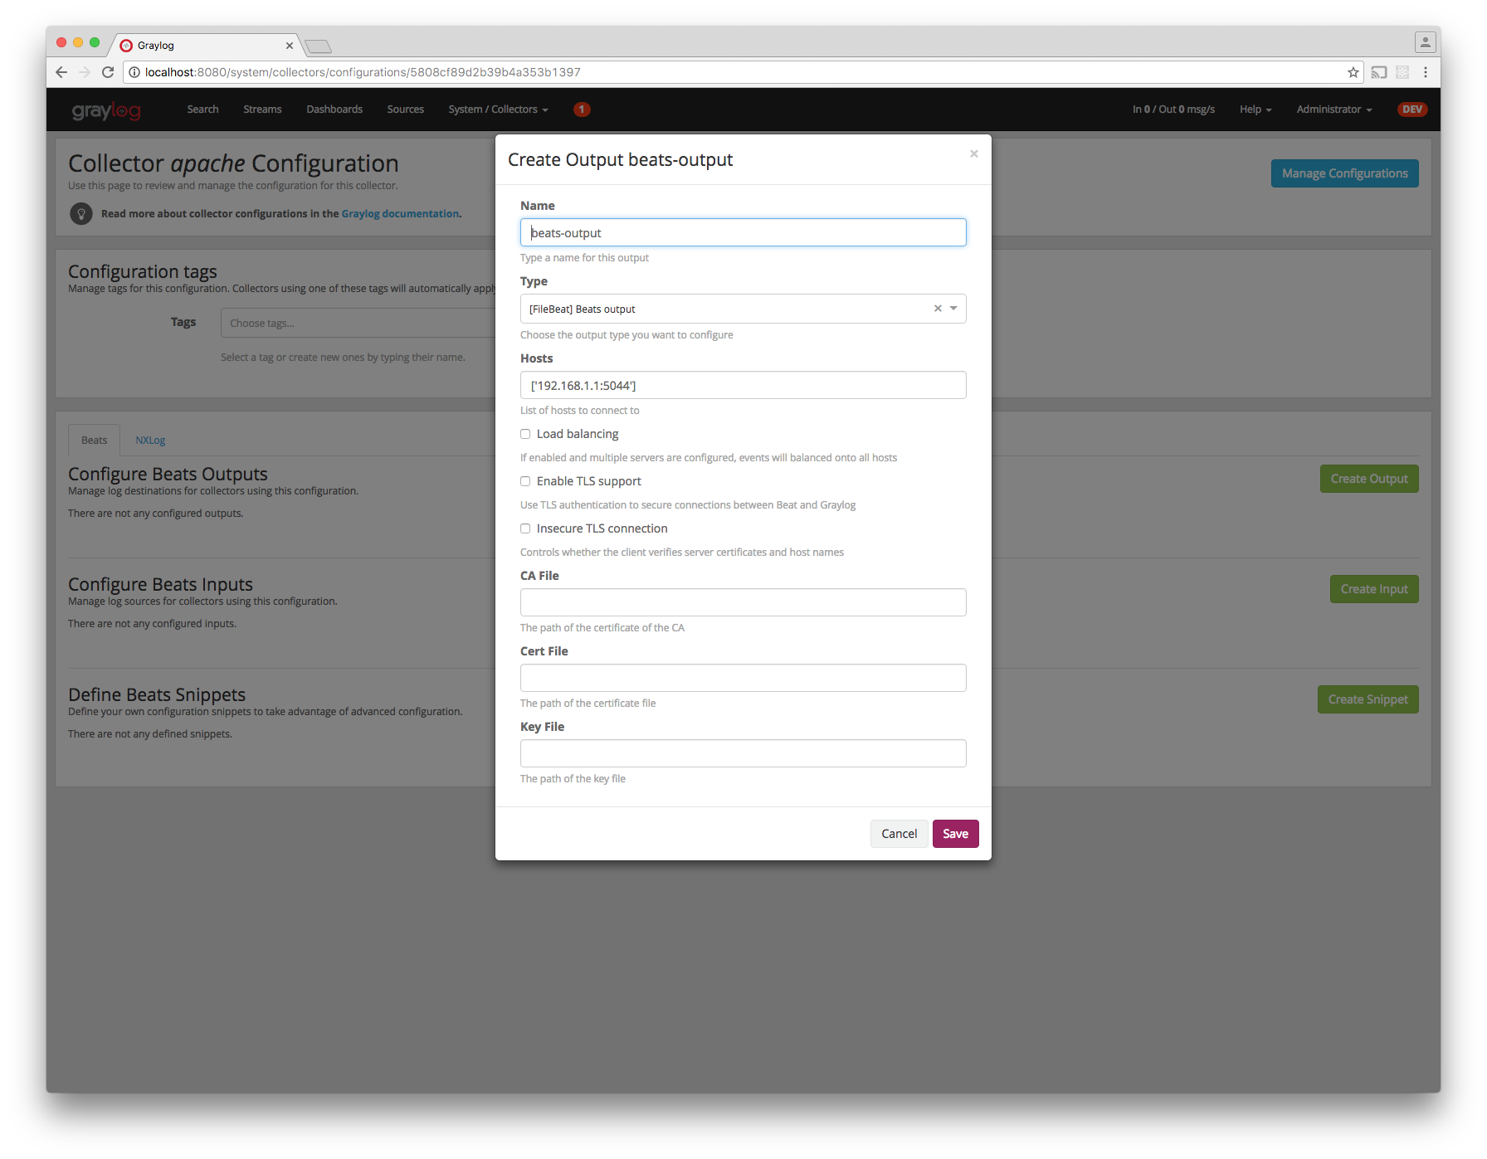
- Create a Filebeat file input to collect the Apache access logs.
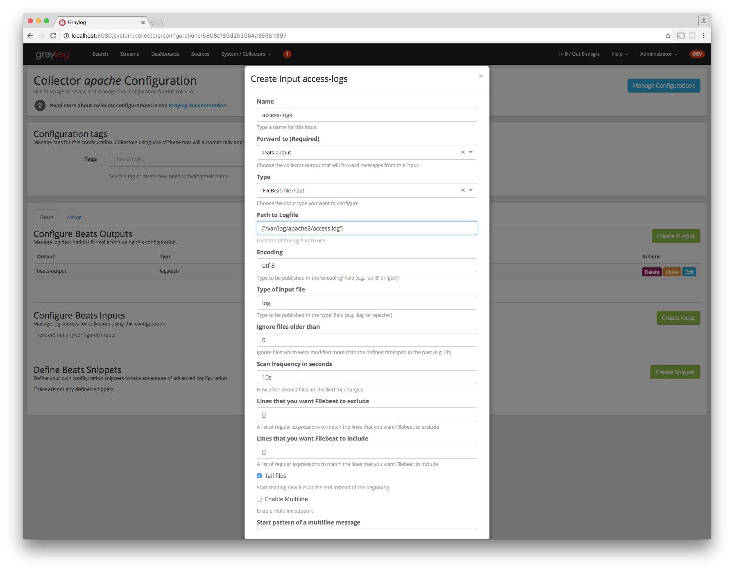
- Tag the configuration with the apache tag. Just write the tag name in the field press enter followed by the Update tags button.
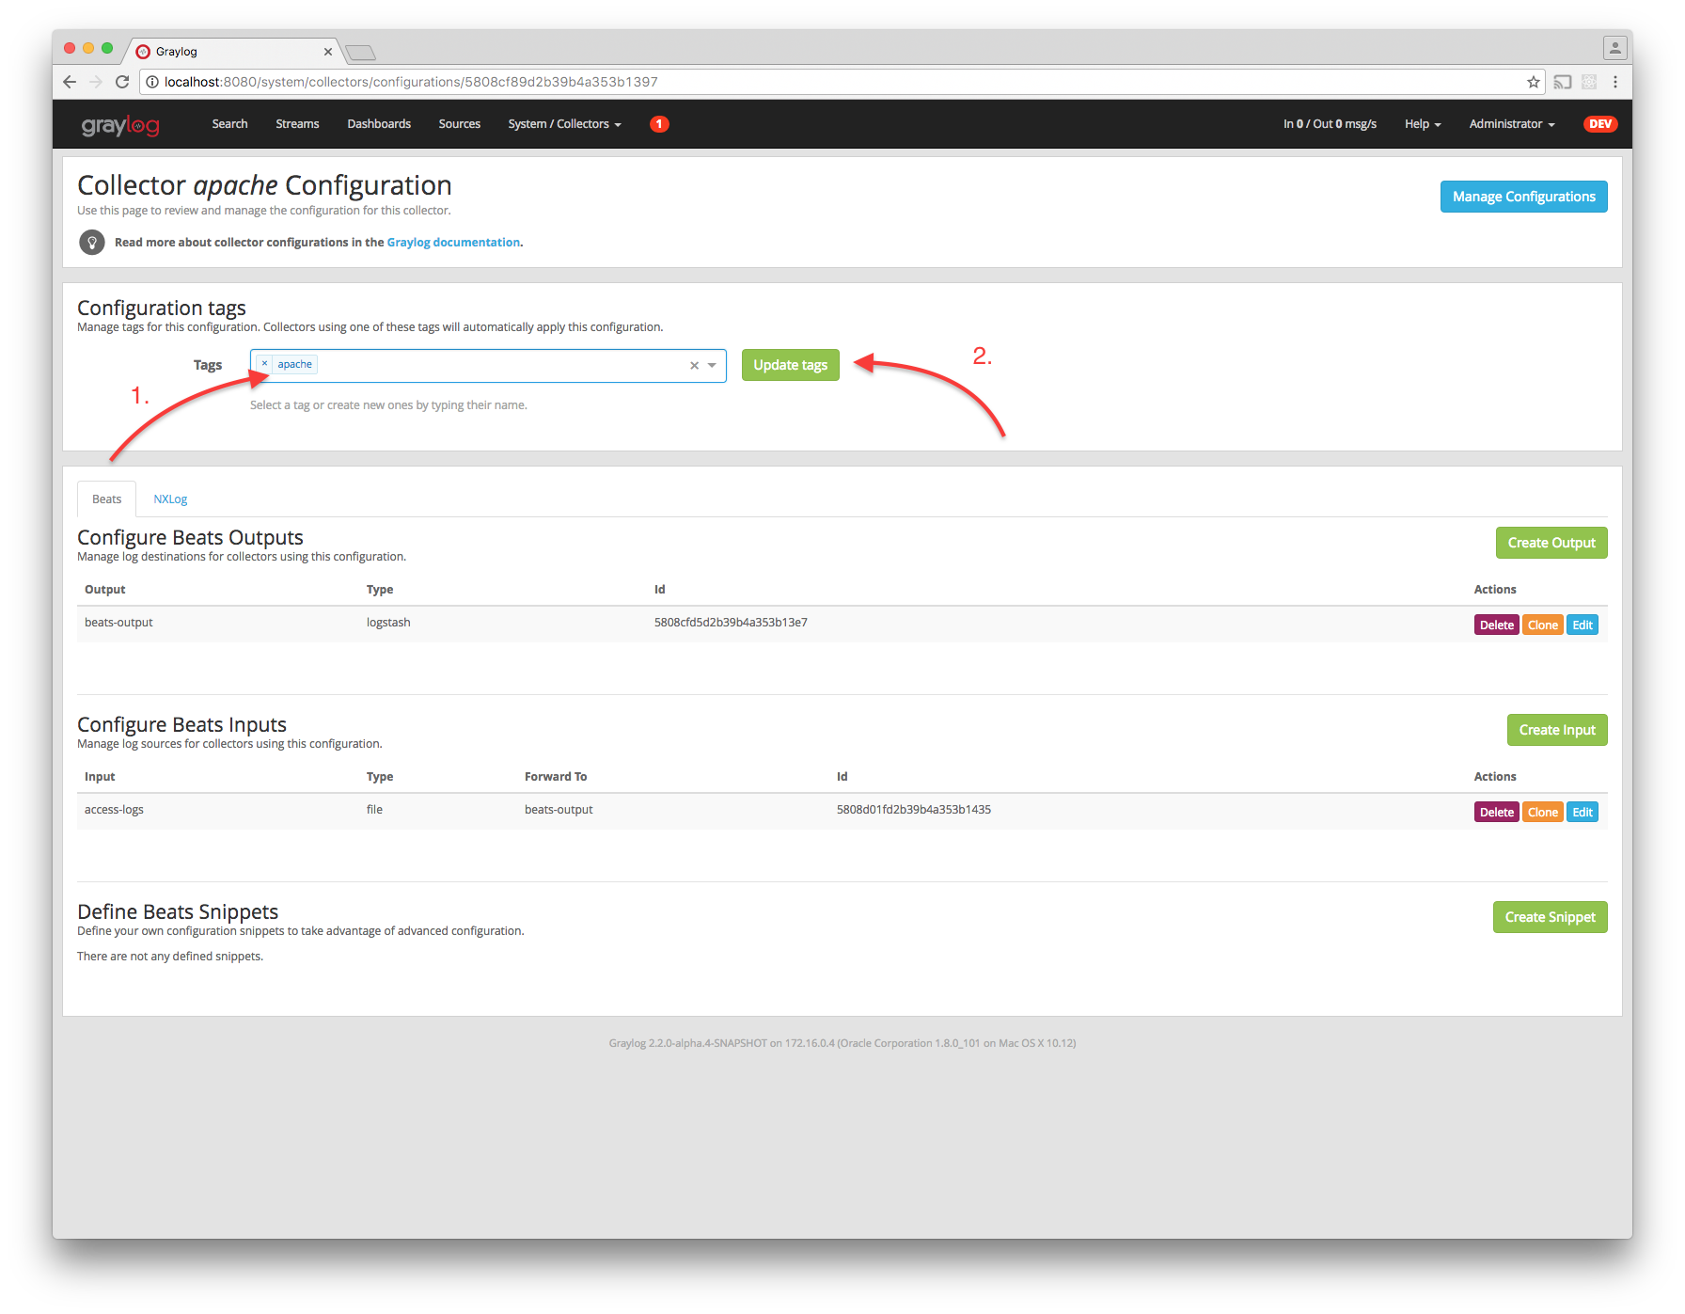
- When you now start the Sidecar with the apache tag the output should look like this
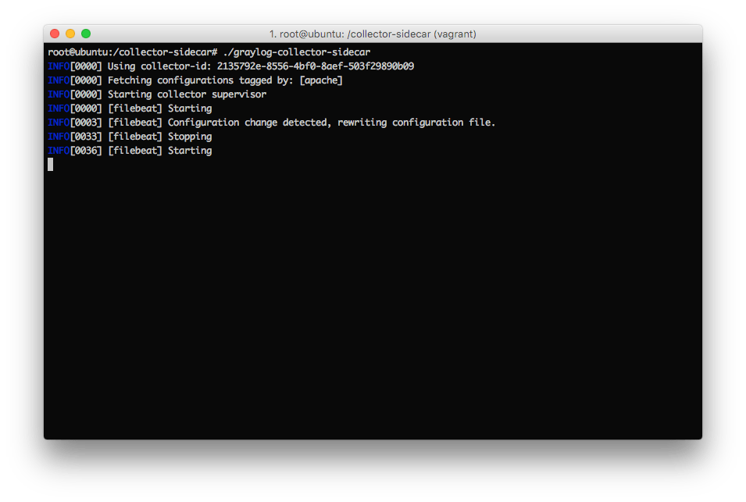
- Congratulations your collector setup is working now!

Secure Sidecar Communication
The Communication between Sidecar and Graylog will be secured if your API use SSL.
To secure the communication between the Collector and Graylog you just need to mark Enable TLSin your Beats Input. Without giving additional Information, Graylog will now create a self-signed certificate for this Input. Now in the Sidecar Beats Output Configuration you just mark Enable TLS Support and Insecure TLS connection. After this is saved, the communication between Beats and Graylog will use TLS.
If you prefer NXLog you need to mark Allow unstrusted certificate in the NXLog Outputs configuration and Enable TLS for your GELF Input.

Certificate based client authentification
If you want to allow Graylog only to accept data from certificated clients you will need to build your own certificate authrority and provide this to the Input and the Client Output configuration.

Sidecar Glossar
To understand the different parts of the Graylog Sidecar they are explained in the following section.

Configuration
A collector configuration is an abstract representation of a collector configuration file. It contains one or many Outputs, Inputs and Snippets. Based on the selected backend the Sidecar will then render a working configuration file for the particular collector. To match a configuration for a Sidecar instance both sides need to be started with the same tag. If the tags of a Sidecar instance match multiple configurations all Out-,Inputs and Snippets are merged together to a single configuration.

Tags
Tags are used to match Sidecar instances with configurations on the Graylog server side. E.g. a user can create a configuration for Apache access log files. The configuration gets the tag apache. On all web servers running the Apache daemon the Sidecar can also be started with the apache tag to fetch this configuration and to collect web access log files. There can be multiple tags on both sides the Sidecar and the Graylog server side. But to keep the overview the administrator should use at least on one side discrete tags that the assignment is always 1:1 or 1:n.

Outputs
Outputs are used to send data from a collector back to the Graylog server. E.g. NXLog is able to send directly messages in the GELF format. So the natural fit is to create a GELF output in a NXLog configuration. Instructing NXlog to send GELF messages is of course just half the way, we also need a receiver for that. So an administrator needs to create a proper receiver under System → Inputs.

Inputs
Inputs are the way how collectors ingest data. An input can be a log file that the collector should continuous read or a connection to the Windows event system that emits log events. An input is connected to an output, otherewise there would be no way of sending the data to the next hop. So first create an output and then associate one or many inputs with it.

Snippets
Snippets are simply plain text configuration fragments. Sometimes it’s not possible to represent the needed configuration through the provided system. E.g. a user would like to load a special collector module. She could put the directive into a snippet which will be added to the final collector configuration without any modification. It’s also conceivable to put a full configuration file into a snippet and skip all of the input and output mechanism. Before the snippet is actually rendered into the configuration file the Sidecar is sending it through a template engine. It’s using Go’s own text template engine for that. A usage of that can be seen in the nxlog-default snippet. It detects which operating the Sidecar is running on and depending on the result, paths for some collector settings change.

Actions
Resources like inputs, output or snippets have all the same actions: create, edit, clone Usually there are only little differences between certain configurations so you can create a resource once, clone it and modify only the fields you need. In this way it’s possible to manage a fairly large amount of configurations.
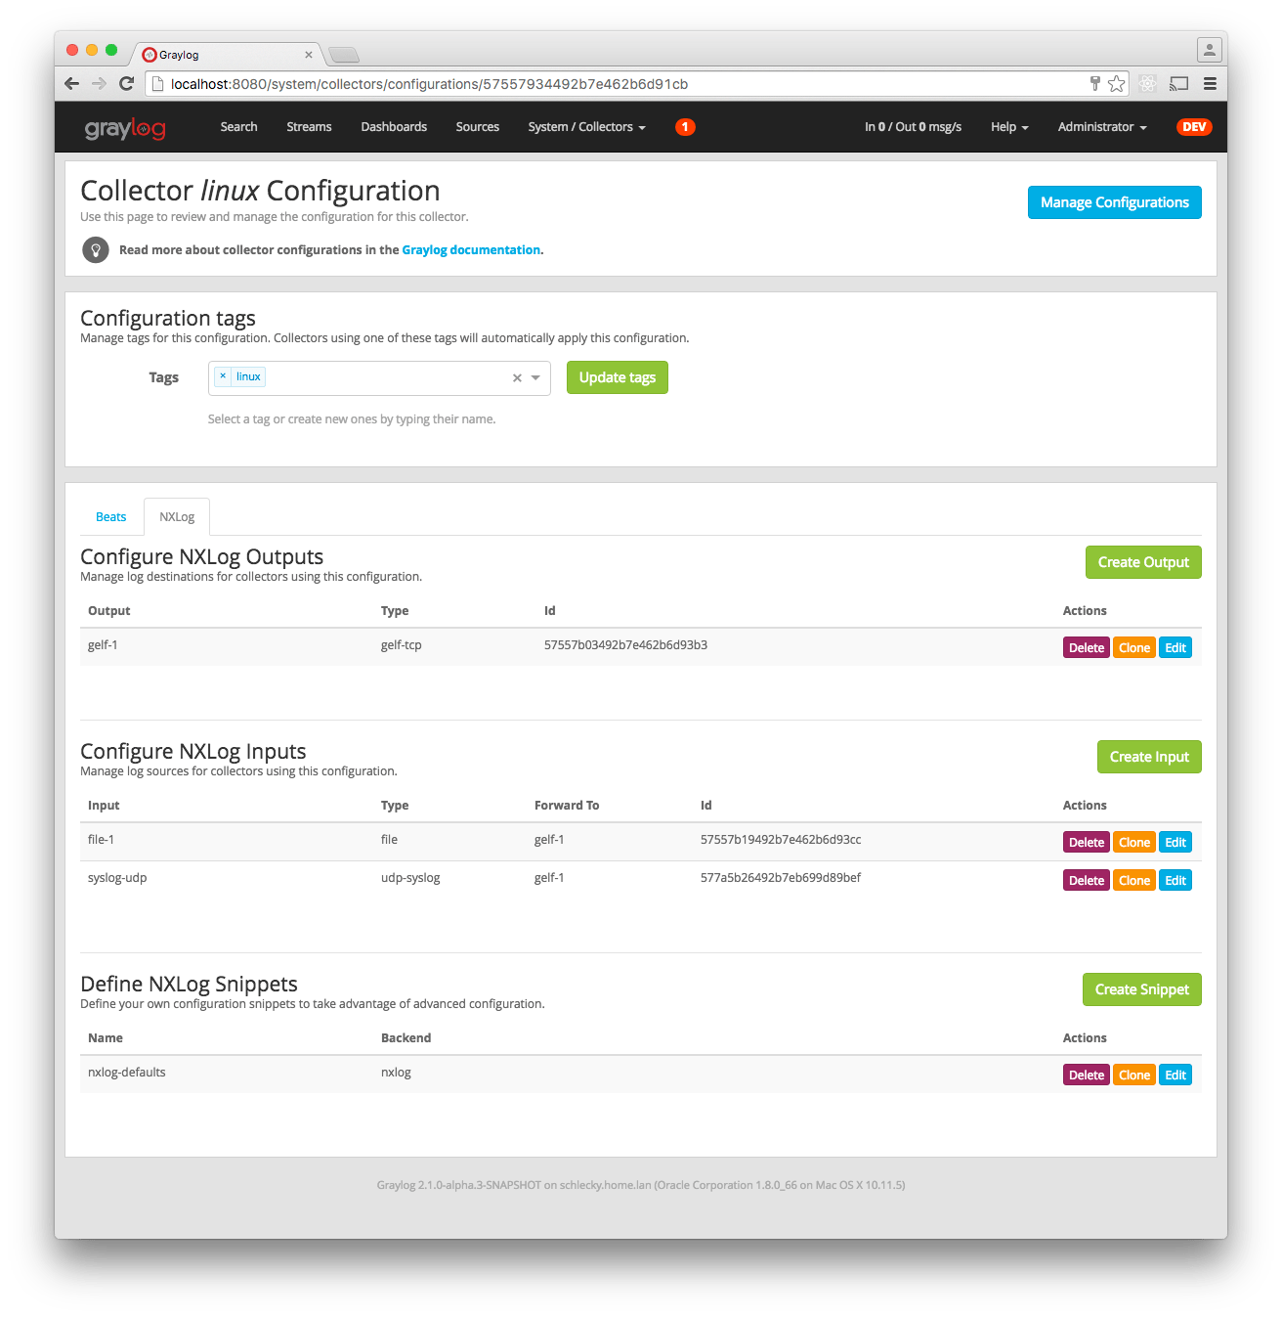

Debug
The Sidecar is writing to the local syslog so take a look into /var/log/syslog for informations why something is wrong. The output of the running collectors is written to the log_path directory.
You can also start the Sidecar in foreground and monitor the output of the process:
$ graylog-collector-sidecar -c /etc/graylog/collector-sidecar/collector_sidecar.yml

Known Problems
Currently we know of two problems with NXLog:
- Since version 2.9.17 timestamps are transmitted without millisecond precision
- On Windows machines NXlog is not able to store it’s collector state so features like file tailing doesn’t work correctly in combination with Sidecar. Use Sidecar version 0.1.0-alpha.1 or newer.

